Some tips and explanation of 0 and 1 identification system :
the input :
1 - x is a matrix 1000*400 1000 row and 400 col this means that we have 1000 examples and then each one have 400 features
2 – y is a 1000*1 matrix this mean that we have 1000 output and each one as 1 or 0 as label
the network :
the neural network that we will use is a simple input → 3 dense layers : where last layer is the output
the activation in each of the neurons in the neural layers is sigmoid
recall on sigmoid :
sigmoid function is an S shaped curve maps any value of -inf to +inf to a value between 0 and 1
it allows the network to learn non linear relationships within data
in binary classification or called logistic regression the function is used to hold the
probability of 0 and 1
sigmoid(alpha) = 1 / (1+r**(-alpha))
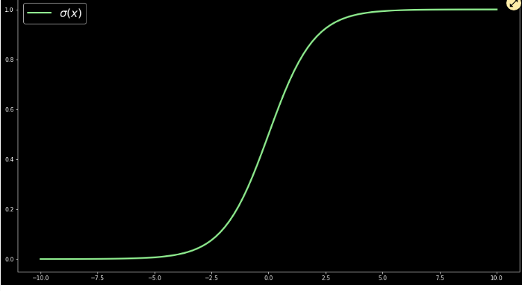

it has some problems when values are so small or so big in gradient descent and that why we use the relu funtion
we will stick to sigmoid here

we said that we will feed the neural network with pixels as 20*20 matrix (row is 400 feature ) then the input for the model is 400

we will produce 25 outputs from the first dense layer that will activate the second layer that will produce 15 activation for the output dense layer .
Lets do some math :
- if we have 400 input and we need to output 25
- we need to 1*400 * 400*25 to produce some 25 outs and then add to them the biasing factor which will be 25*1
- and with this we produce 25 outs / motivations
- for the second layer we need w to be 25*15 and b to be 1*15
- for the third one we need to only have a single ouput so we will handle the 1*15 by 15*1 and add to it a 1*1 biasing factor
Tensorflow model implementation :
its built layer by layer the ouput of one layer is the activation of the second one and so on .
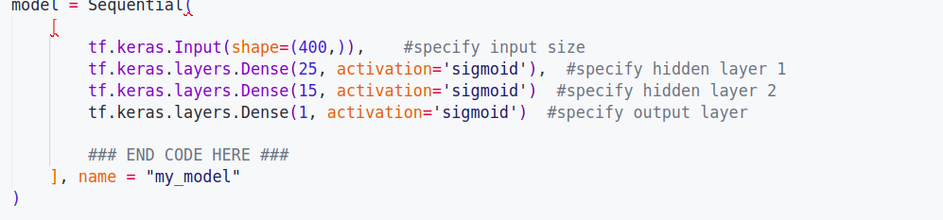
Input size can be specifies by 2 ways either by model.fit or by specifying the input layer explicitly

model intialization:
we can call layer.getweights() to examine w and b for the specified layer and then we can printthere shape and they will be as we disscussed earlier
by compiling the model we are fit the weights to data set and then we run the gradient descent to take the optimal ones
then safely we can predict any of our tests from the test data set

now lets implement the same thing in numpy using forward propagation :
this means we can build our own dense layer by numpy
how to build such layer :
we need to perform iteratively a loop that takes every col of w cross it will the full row of input and then add the corresponding jth unit of bias vector assemble the a_out j by j dont forget the sigmoid implementation

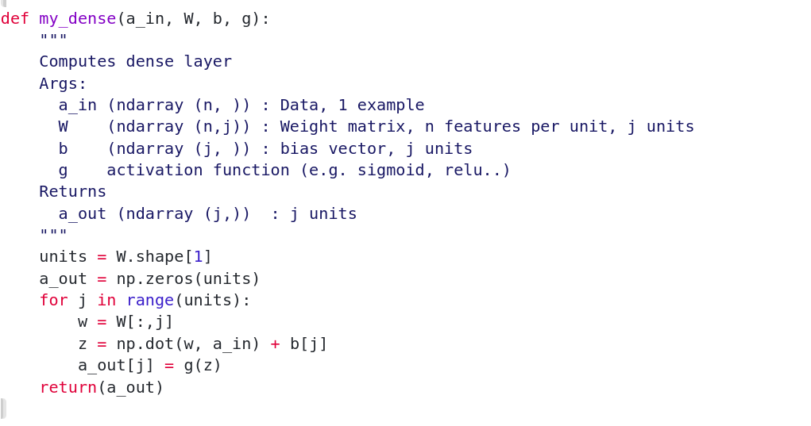

\

we need other def which is sequential that links the layer with each other
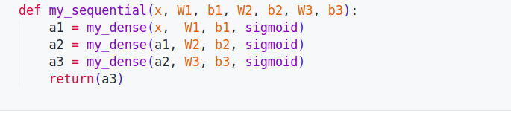

and finally we can using numpy matrix multiplication:
- take the row that is ur input 1 cross 400
- then matmult this with the 400 25 matrix w and add the 25 1 bias factor to it
- then apply sigmoid
- and return
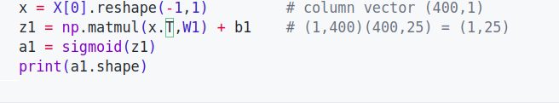

some matrix multiplication tips :
